**PERFORM DIMENSIONALITY REDUCTION OPERATION USING PCA, KPCA & SV**

**EXP.NO.: 05**

# AIM

To perform dimensionality reduction using Principal Component Analysis (PCA), Kernel PCA (KPCA), and Singular Value Decomposition (SVD) on the *mtcars* dataset.

# TOOLS REQUIRED

* RStudio / R environment
* stats package (for PCA & SVD) – comes built-in with R
* kernlab package (for Kernel PCA)
* ggplot2 package (for visualization)
* ggfortify package (for enhanced PCA biplot)

# ALGORITHM

* Install and load required packages (stats, kernlab, ggplot2, ggfortify).
* Load the mtcars dataset and standardize it using scale().
* Apply PCA using prcomp() and examine variance using summary().
* Visualize PCA using autoplot() with variable loadings labeled.
* Apply Kernel PCA (kpca()) with RBF kernel and visualize first two components using ggplot2.
* Perform Singular Value Decomposition (svd()) and plot the first two left singular vectors using ggplot2.
* Compare and interpret results from PCA, Kernel PCA, and SVD.

# CODING

install.packages("ggplot2") install.packages("kernlab") install.packages("ggfortify")

library(ggplot2) library(kernlab) library(ggfortify)

data(mtcars)

df <- scale(mtcars)

pca_result <- prcomp(df, scale. = TRUE)

summary(pca_result)

autoplot(pca_result, data = as.data.frame(df), loadings = TRUE,

loadings.label = TRUE, loadings.colour = "blue", loadings.label.size = 4,

main = "PCA Biplot - mtcars (Enhanced)")

kpca_result <- kpca(~., data = as.data.frame(df), kernel = "rbfdot")

kpca_df <- as.data.frame(rotated(kpca_result)) kpca_df$Car <- rownames(df)

ggplot(kpca_df, aes(x = V1, y = V2, label = Car)) + geom_point(color = "steelblue", size = 3) + geom_text(vjust = -0.5, size = 3) + theme_minimal() +

labs(title = "Kernel PCA (First 2 Components) - mtcars", x = "PC1", y = "PC2")

svd_result <- svd(df) print(svd_result$d)

svd_df <- data.frame(U1 = svd_result$u[,1], U2 = svd_result$u[,2], Car = rownames(df))

ggplot(svd_df, aes(x = U1, y = U2, label = Car)) + geom_point(color = "darkgreen", size = 3) + geom_text(vjust = -0.5, size = 3) + theme_minimal() +

labs(title = "SVD Components - mtcars", x = "U1", y = "U2")

# OUTPUT

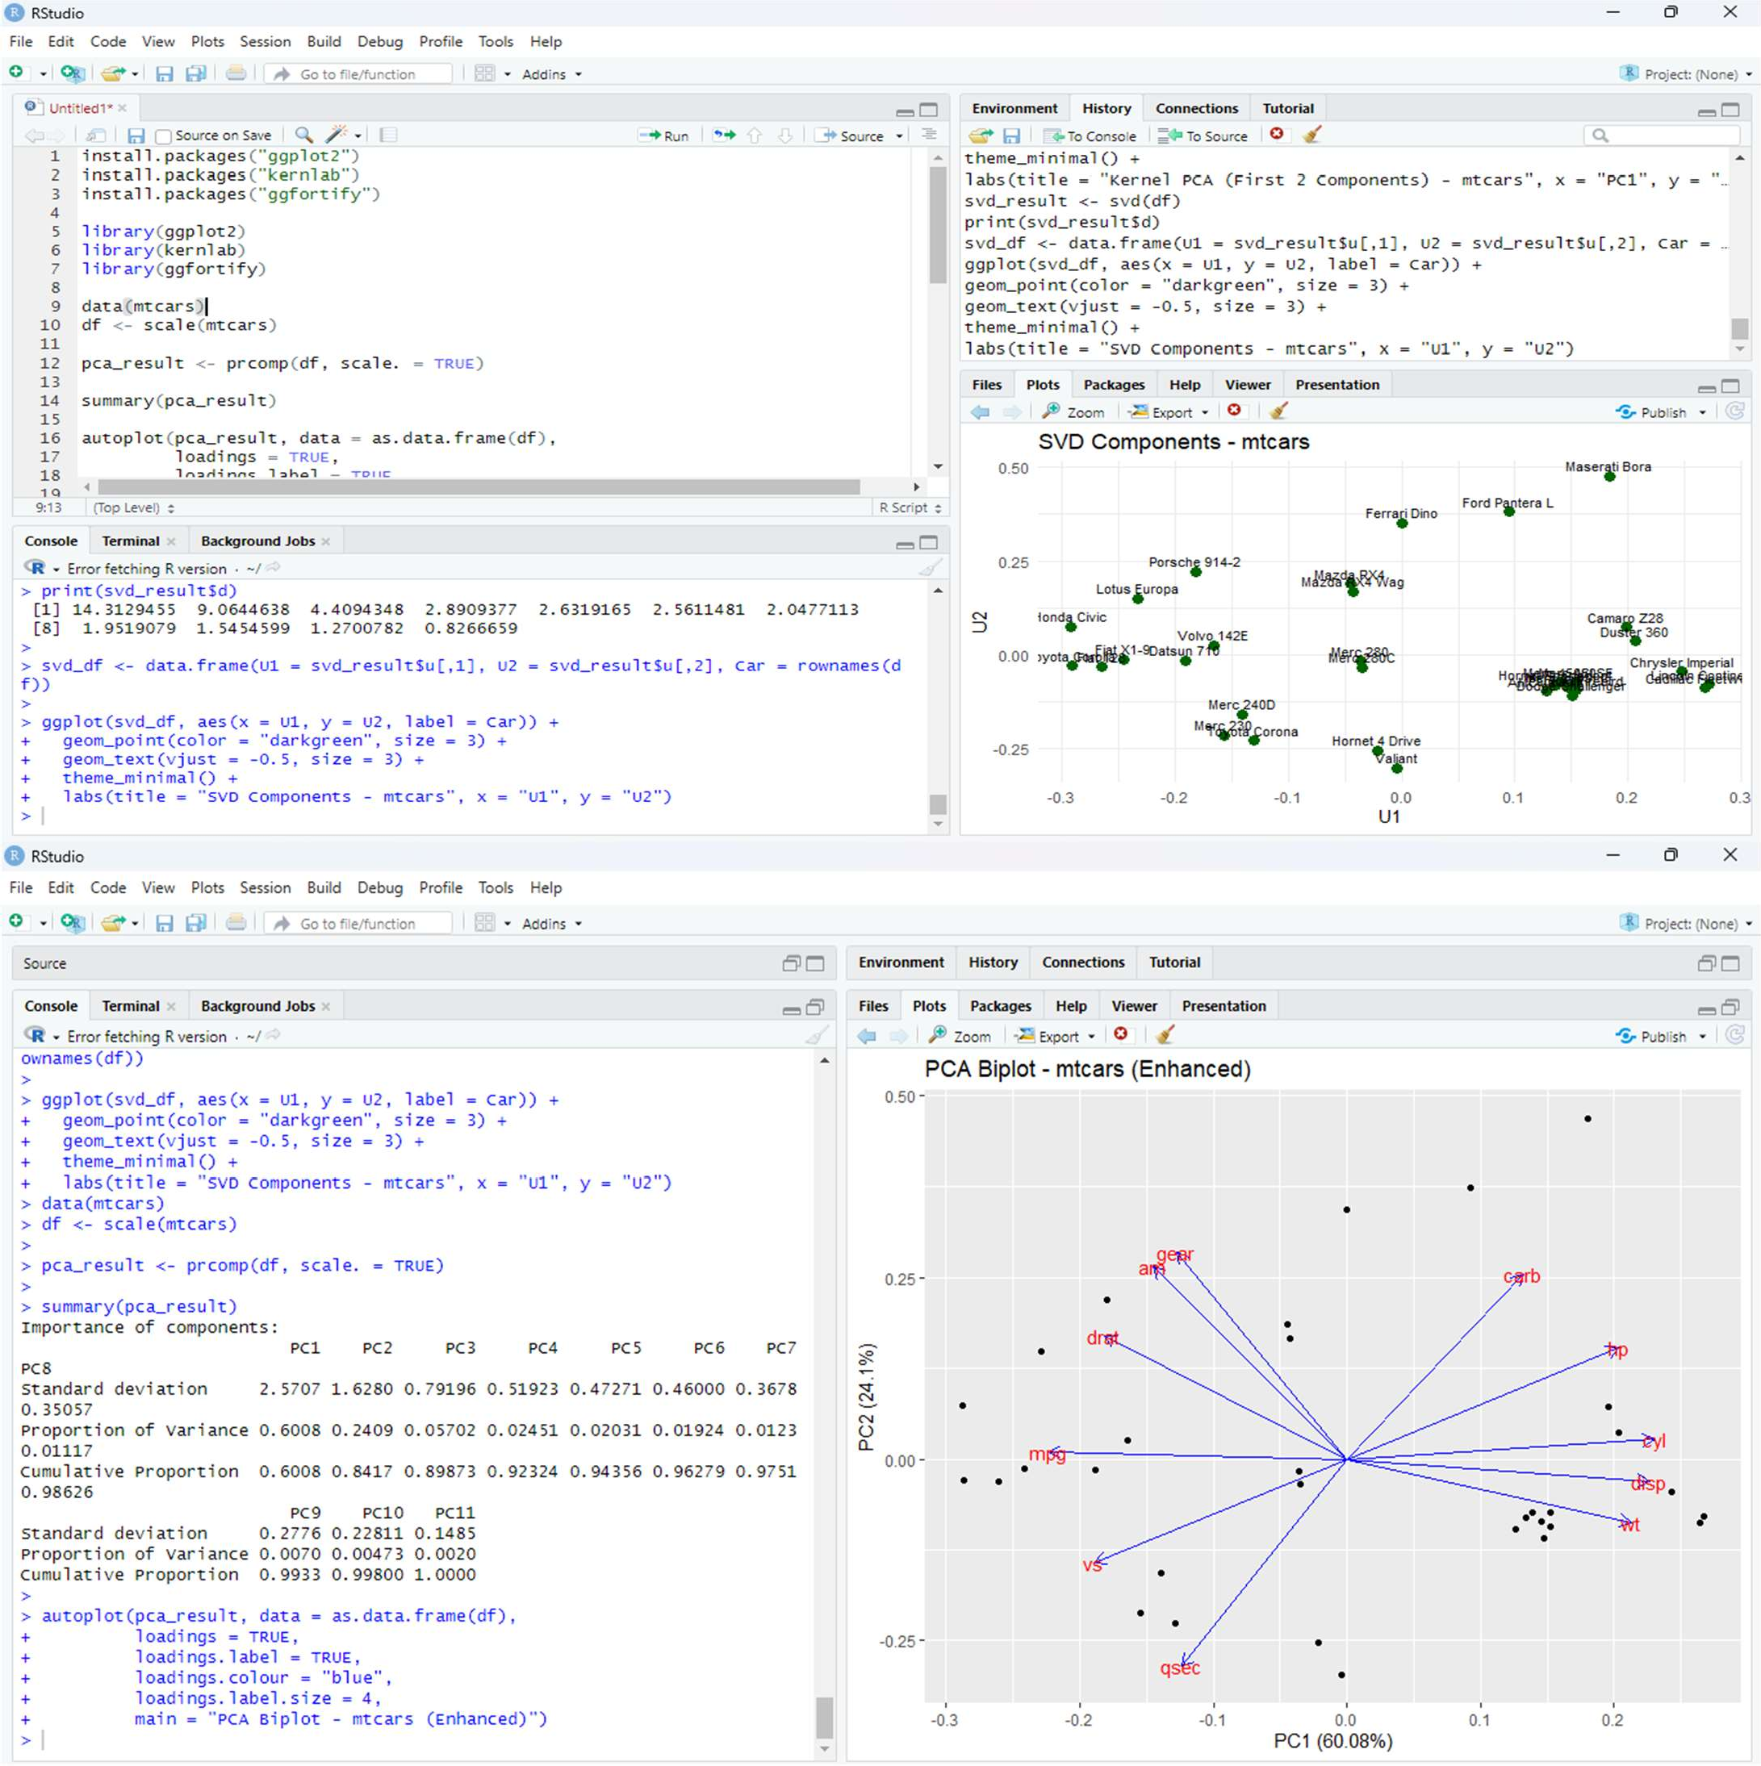

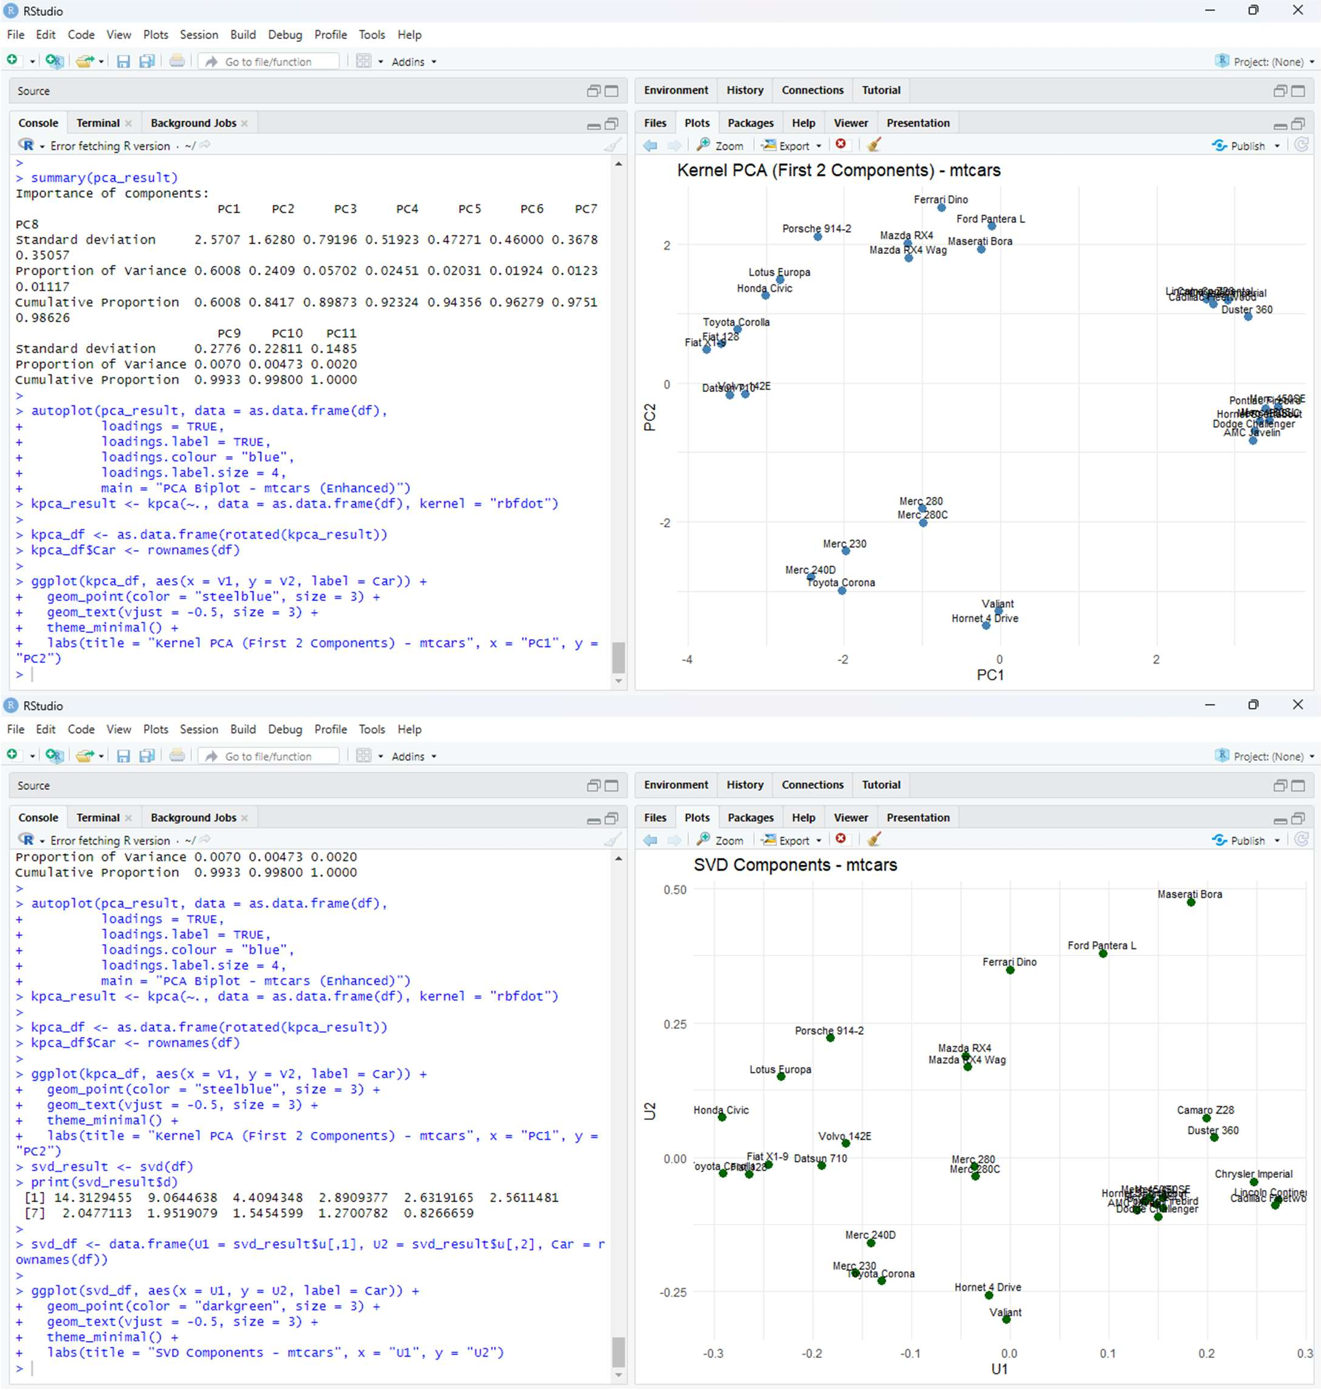

**RESULT**

Thus successfully completed dimensionality reduction on the *mtcars* dataset.The reduced components effectively preserved major variance and improved visualization.